Homework for week 1, submission deadline 23:59 on Sunday night.
- Complete an Omics-to-Question map: Using your own research project or biological interest. What kind of omics you plan to use to solve the biological research question?
Biological research question: Identify key molecular changes in high-fat-diet induced mouse NAFLD and the crosstalk between liver and gut microbiota.
- Liver transcriptomics (RNA-seq) Used to detect differentially expressed genes and activated signalling pathways in fatty liver tissue.
- Liver & serum metabolomics Used to characterize altered small-molecule metabolites, revealing hepatic metabolic disorder under high-fat diet.
- Fecal metagenomics Used to profile gut microbial composition and functions for exploring gut-liver axis interactions.
- Write one weak prompt and one CARE+V prompt: For the same biological or research question, propose a weak and strong (CARE+V) prompt that can be tested by AI. Use any LLMs to test your prompt and paste the output results below.
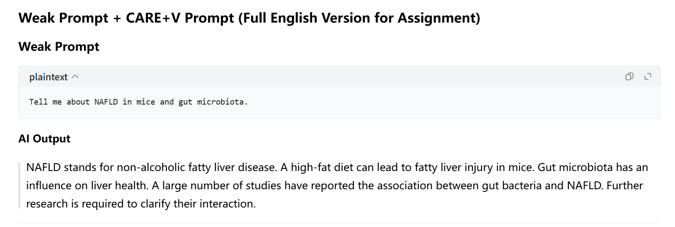
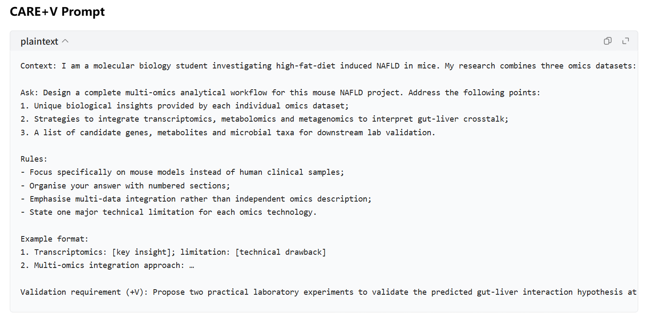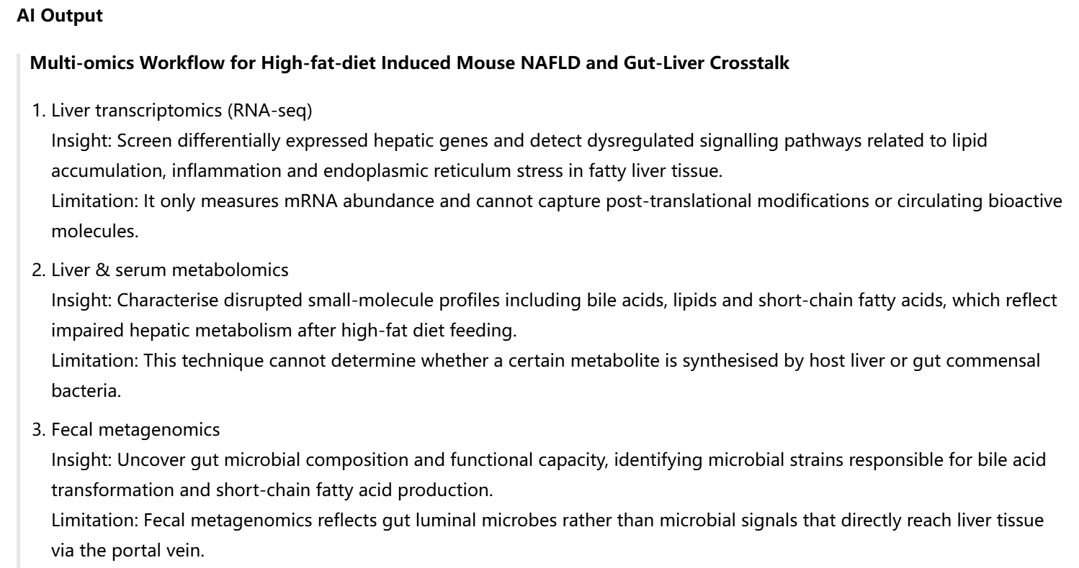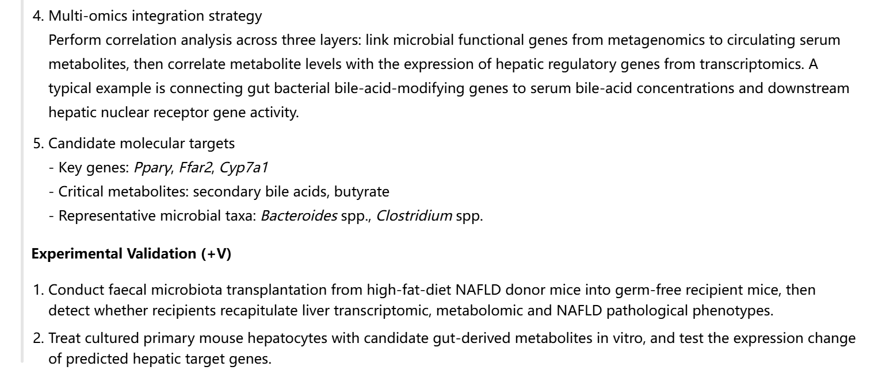

3. Install and Run R and RStudio and save output showing R version and packages.
R: https://cran.r-project.org/ RStudio: https://posit.co/products/open-source/rstudio.
Once installation, please paste a screen cut of Rstudio here. Give a try of R to using the foler (Week1_R_RStudio_Practice_Files) code and data.
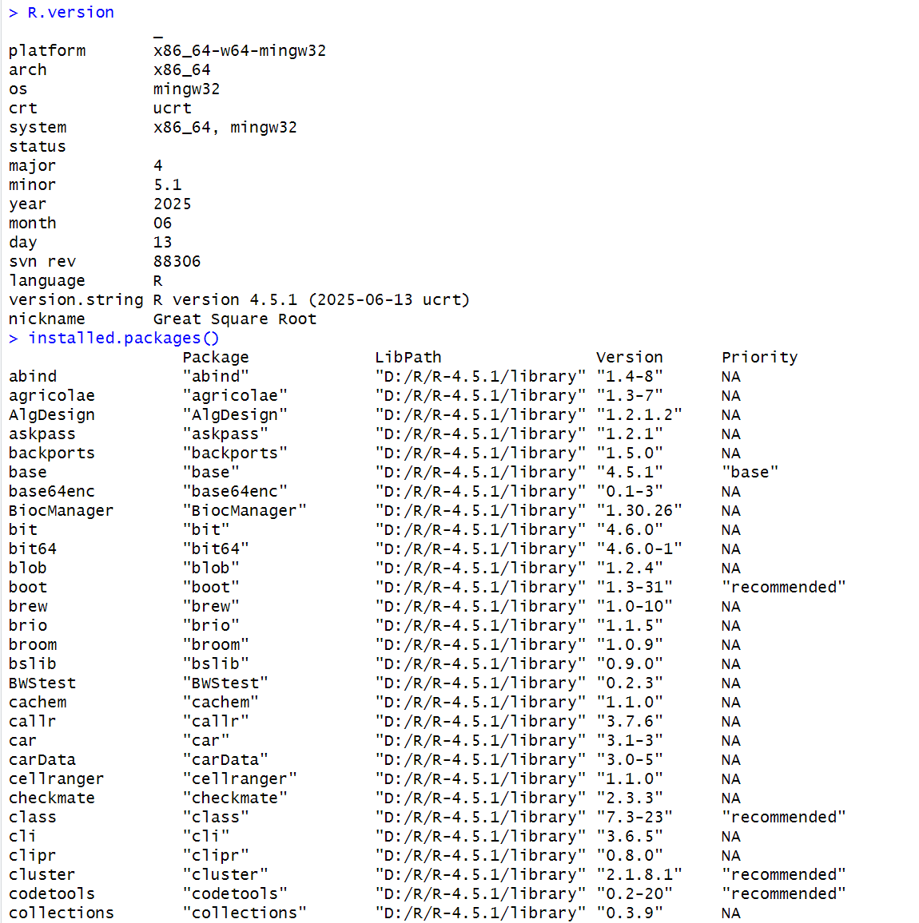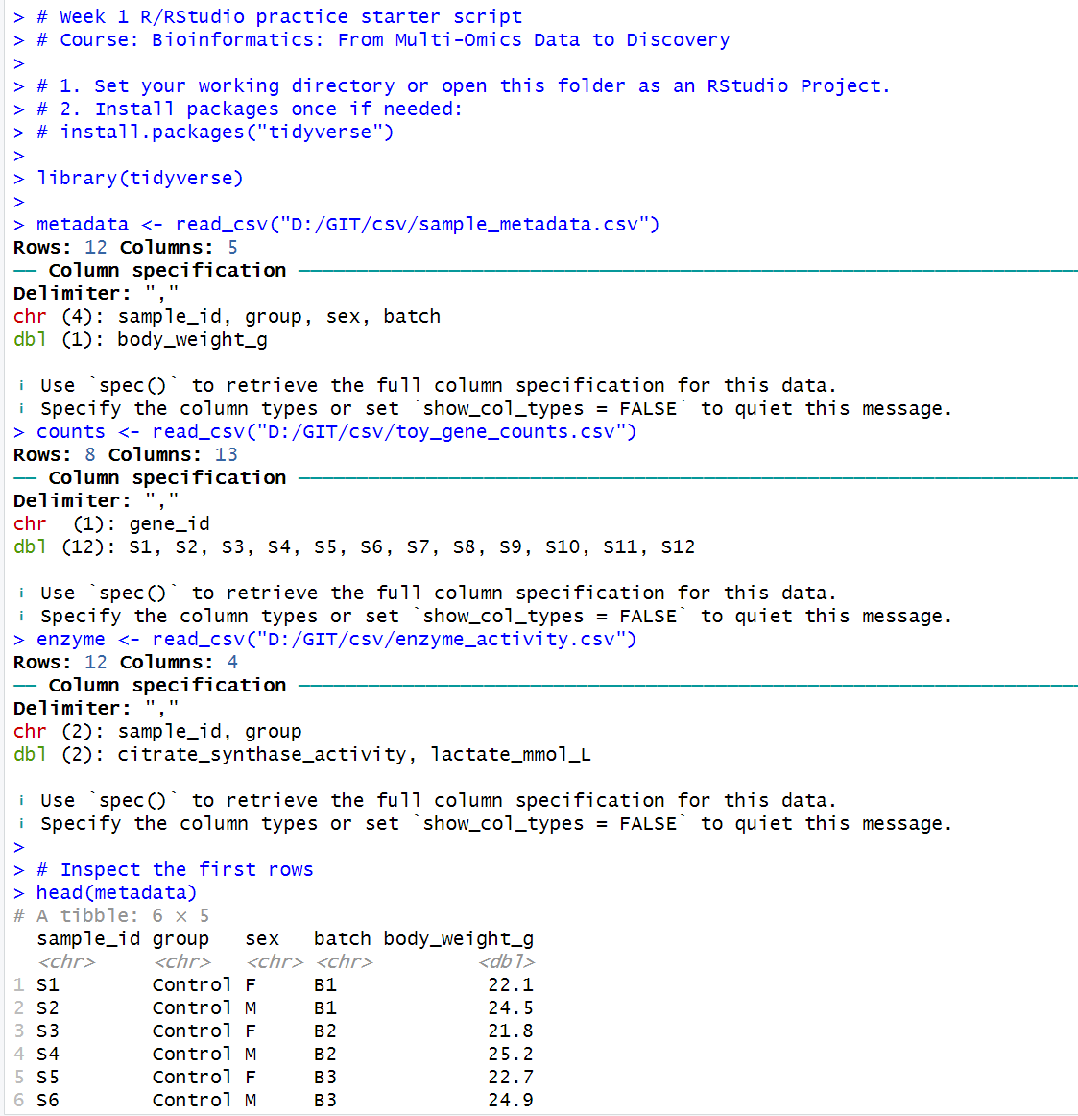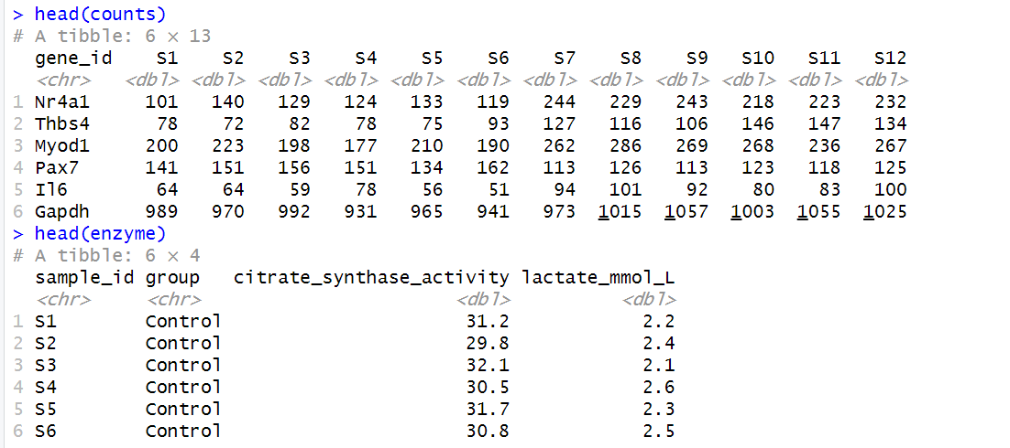

4. Install agent and create your first prompt log entry documenting AI use and verification.
4.1 Github:https://www.github.com/ (Create your account and repository for your homework submission). You need an account and a repository for homework submission (following the pattern: Bioinformatics_homework_Yourname_ID). You also need personal access token in together with repository link to activate your EasyMultiProfiler-web account.
4.2 Hermes-agent: https://github.com/NousResearch/hermes-agent (Install agent for coding) and Hermes WebUI (https://github.com/nesquena/hermes-webui)
4.3 Codex: https://chatgpt.com/codex/ (Install for coding and agent)
4.4 Deepseek API: https://platform.deepseek.com/usage (Top up ¥10 for agent set and switching to LLM accessed only on SUAT campus) or NVIDIA API

5. Install EasyMultiProfiler and EasyMultiProfiler-Web for multi-omics data analysis and homework submission (You can use Hermes or Hermes WebUI to complete the installation step)
EasyMultiProfiler: https://github.com/liubingdong/EasyMultiProfiler
EasyMultiProfiler-Web: https://github.com/xielab2017/EasyMultiProfiler-Web
